TURKIYE SCHOLARSHIPS
TURKISH SUMMER SCHOOL 2014 PROGRAM
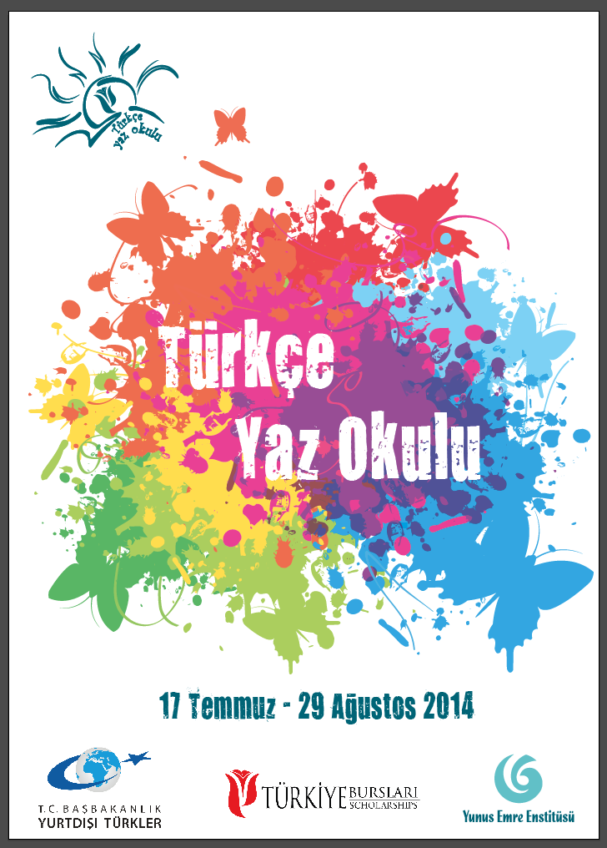
Turkish Prime Ministry Presidency For Turks Abroad and Related Communities organizes Turkish Summer School in cooperation with Yunus Emre Institute for foreign students who wish to improve his/her Turkish language proficiency. The participants will find the opportunity to study Turkish language, to recognise the Turkish culture and to visit prominent touristic and historical heritage of the city where they attend the summer school.
Turkish Summer Course will be held at Turkish teaching centers located in various cities including Aydın, Bolu, Bursa, Denizli, Edirne, Eskişehir, Gaziantep, Kayseri, Konya, Sakarya, Samsun and Trabzon. During the summer school, students will attend Turkish courses till noon, and then they will have the opportunity to enjoy memorable trips and learn about Turkish culture by participating in activities such as wedding ceremonies, summer festivals etc.
Turkish Summer School will end with a special program in İstanbul. Participants in different cities will gather in İstanbul where they will find an opportunity to discover the magnificient city for four days. The participants will visit historic city of İstanbul surrounding Topkapı Palace, Hagia Sophia Mosque, The Blue Mosque and Dolmabahçe Palace. The Summer School will end with a special closing program.
Important Dates
Last date for application: 16 April- 4 May 2014
Summer School Dates: 17 July-24 August 2014
25-29 August (İstanbul Trip and Closing Program)
The Opportunities Offered
- 500 TL pocket money
- Free Accommodation
- Free breakfast and dinner (lunch belongs to student)
- Free health insurance
- Free social and cultural activities
Transportation:
International and domestic round-trip transportation expenses belongs to the participants.
Application Requirements
a) Being a citizen of any country other than the Republic of Türkiye (the candidates who have citizenship of the Republic of Türkiye and also those who lost Turkish citizenship for any reason cannot apply for the Turkish Language Summer School 2014 Program)
b) Being a student at Yunus Emre Turkish Culture Centers or being a student in a university outside Türkiye.
a) Being between the age 18 and 27.
b) For university students having at least 70% weighted grade point average and a proof of Turkish language skills.
c) For Yunus Emre Turkish Culture Center students having at least A1 Level Turkish Certificate.
d) Those who received Turkish summer school in the previous years cannot apply the Summer School.
e) Those who has completed any level of his/her education in Türkiye cannot apply the Summer School
Required Documents
1 - Student Certificate taken from the university or Turkish Certificate taken from Yunus Emre Turkish Culture Centers.
2 - Copy of a valid identity certificate
3 - 1 photo
4- Transcript for university students.
The applicants are required to fill in the application form in the link below.
http://www.turkiyeburslari.gov.tr/formlar/yazokulu/

